LP Services system update – June 26

- Learning Provider Portal – System enhancements delivered
Summary | Description | Implementation date
LP Portal homepage | Remove portal restriction messages that pre-date the current and previous academic year (AY). | 08/02/2026
Loan Position Report (LPR) removal | We have now removed the LPR, due to the additional features within the Payment Instalment Report (PIR). | 14/12/2025
Change of Circumstance (CoC) Submission Report | We’ve relocated the CoC Submission Report alongside other reports within the LP Portal in the reports tab in financial reports. | 12/10/2025
CoC Submission Report | Within the CoC submissions report, the Learning Aim Details heading will display as a hyperlink:  When you select the link, a breakdown of Learning Aim Type CoCs, totals and percentage of learning aims and percentage of total CoCs is displayed:  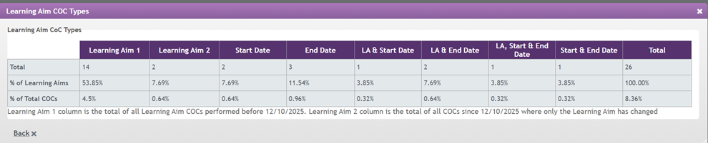  The Learning Aim 1 column is the total of all learning aim CoCs performed prior to 12/10/2025 and the Learning Aim 2 column is the total of all learning aim CoCs after 12/10/2025, where only the learning aim has changed. | 12/10/2025
PIR | We’ve added a new ‘Number’ column to the left-hand side of the PIR and export which will show the total amount of applications included in each row.  Removed the “Submitted and Progressing Applications” box section at the top of the report. | 24/08/2025
PIR | Added an ‘Awaiting Validation’ row within the not approved for payment section on the PIR and the export facility, to give visibility of applications awaiting further evidence. | 27/07/2025
CoC effective date | Removed the pre population of the CoC effective date. Rather than defaulting to the current system date, you will have to enter the effective date. This will be mandatory and if no date has been entered an error message will be displayed. | 27/07/2025
Correspondence section - Missing Evidence hyperlink | For “Identity’, within the Missing Evidence link in the Assessment Information tab, the reference to ‘ADIF’ has been removed as an evidence document and the description for ‘Birth Certificate’ has been updated to advise that either a photocopy or original is now acceptable. | 27/07/2025
PIR | With the introduction of E-Signature, applications no longer go to the workstage of ‘Approved Awaiting Signature’. This column has been removed from view within the PIR as well as the export facility. | 27/07/2025
Withdrawal error message | Update error message when performing a Withdrawal CoC where the effective date falls on a month where the current status is ‘Not in Attendance’. This is to make it clearer as to why the CoC is not accepted. | 08/06/2025

- LP Portal – system enhancements under analysis

Summary | Description | Status
Detailed Learner Information/Assessment Information/Application State | Add hyperlink to awaiting validation status to show what evidence is required and has been requested from the learner. | Under analysis
Learning Provider Details page | De-activate both the Profile and Contract Manager edit buttons. Any changes the LP attempts to submit are not updated via the LP Portal. | Under analysis
CoC Worklist | Add the facility to export the data. | Under analysis
CoC | To enable providers to submit a fee change CoC at the same time as withdrawing an application, where it has previously been suspended. | Under analysis

